**Section 13 done: 17/17 Forms and Form Validation  
Introduction**  
* In general, we haven’t talked too much about forms in this course yet.  
* We talked about handling input with two-way binding and this often is enough.  
* But if you have a form and you also want to validate that form, that is something that can be complex due to the way React works due to it being just JavaScript.  
**Analyzing the App**  
* In the Checkout page in the ContactData container there, we see that we got some general state set up at the top and we also in there have our submit method -orderHandler- where we submit our order to a server and where we also pass some data.  
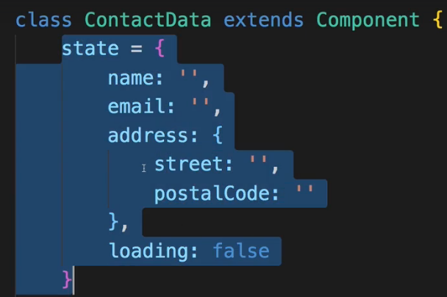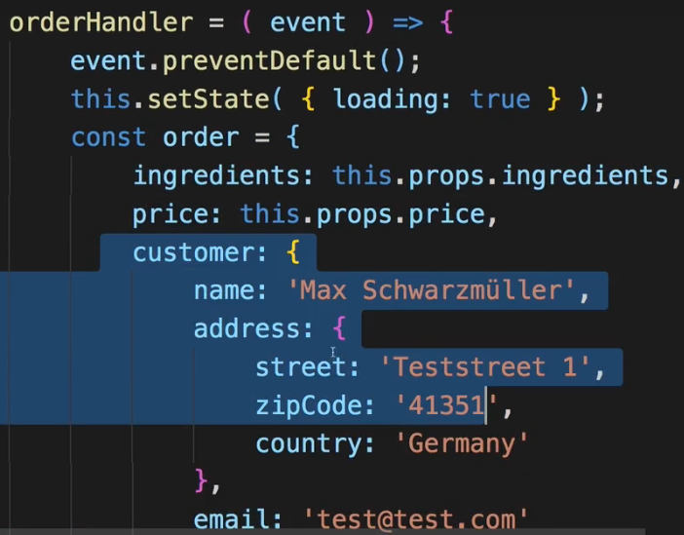  
* Now the customer data which is set up in orderHandler is not synced to this state at all, actually not even the fields are equal. Now part of this module will be to sync that up.  
* But also if you we look at our form, we currently don’t really handle their input, we don’t really handle when the value changes.  
=> First we will decide which kind of data we need, that we then store this in the state, then it would be the best if we even find a way of dynamically generating our form and then of course as the last step, also not only handle the form submission but also check the form validity and change the styling of our form based on the validity for example.  
* I’ll start by putting these input elements into custom components, which have a standardized styling, maybe have a default label, and also later will be extended to have room for error messages.  
**Creating a Custom Dynamic Input Component**  
* In the `UI` folder we create`Input` folder, you could also create `Form` folder and have it inside it.  
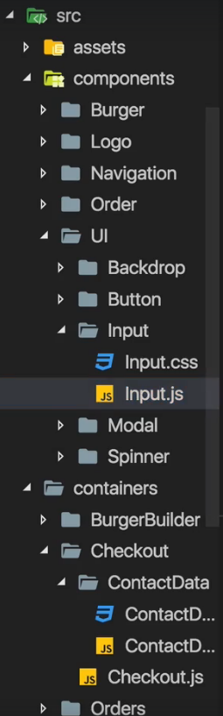  
* This component is made for inputs, if we want to write a more generic method, we should actually have a check of what our input really is. Something like this:  
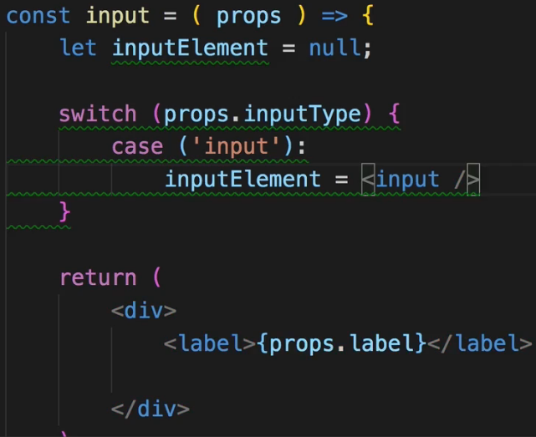 * We would of course add more values to the switch statement.  
* And you can reach any amount of complexity here because now of course you also have different attributes per elements you might have so if you also have the case textarea, that doesn’t take the same attributes a normal input element does. Now all of a sudden we might face certain restrictions.  
* **textarea is a self-closing element in React**.  
* So this is some complexity we’ll have to handle either by creating multiple custom components for the different input types you might have so that we basically have a wrapper component for normal inputs, for textareas, whatever, or by simply adding such a switch statement.  
=> Now I’ll go for the switch statement approach.  
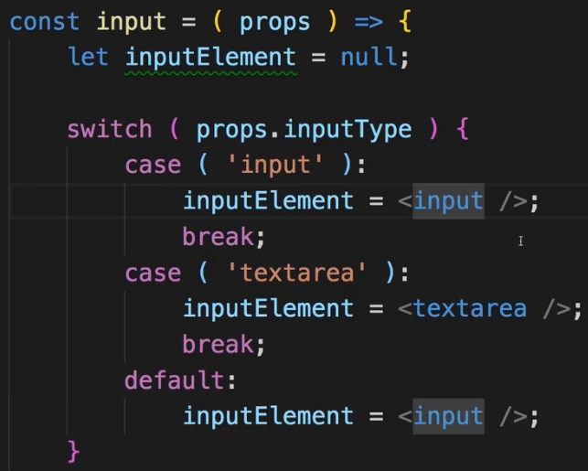  
=> To handle the case that we also have different attributes, I expect to get the attributes you wanna set on an input, as props for our Input wrapper. This then allows me to simply distribute them on the input element. So any default HTML attributes you wanna set on your input, you only need to set the inputType prop and then you pass the normal attributes you would pass to that type. So if you have a textarea, you simply pass the normal props you wanted to pass from outside. And inside of my custom input component, I don’t have to worry about which exact type we have, I rely on you using the wrapper correctly and passing the correct normal HTML attributes.  
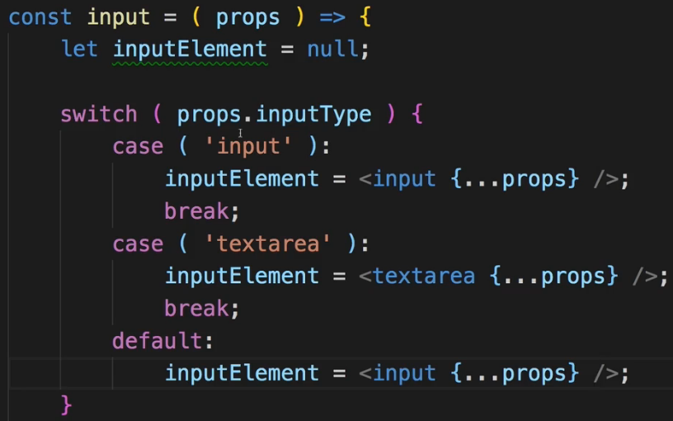  
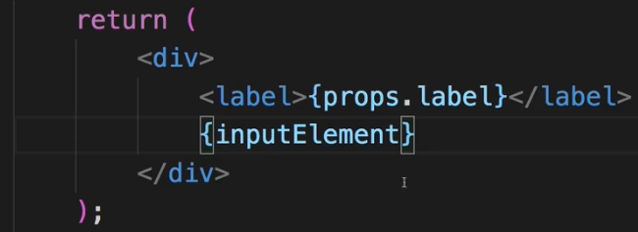  
* This is a way of reducing the complexity here so that I only have to set the right element and then you take care about the props.  
* Now we can add more elements here of course like a dropdown, a select element and so on.  
* For now this is the setup I wanna use. Obviously I also want to style this now.  
* First of all I want to make sure that the DIV which I will use to assign this class, wrapps the full width of the available space, so 100% let’s say. My .Label should also be of display: block so to take the full width, to take its own line, its own row in our HTML. Setting the font of .InputElement to inherit to use the normal font settings we have for the rest of the application. The .InputElement should also be display: block, and should take the full available width let’s say so that it really takes the full width it can take. +++ should also have box-sizing: border box.  
* And we’ll give the elements the classes.  
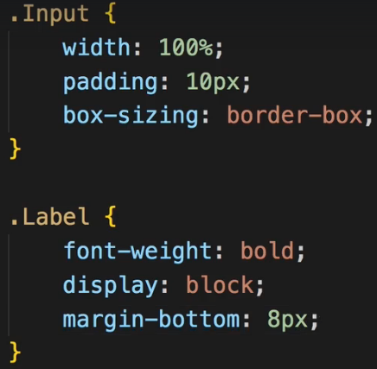 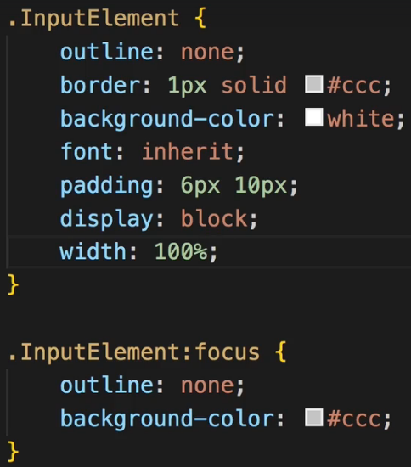   
* Now you can of course define way more styles, you can add a :disabled style or whatever you want.  
* In ContactData let’s use our custom Input element now.  
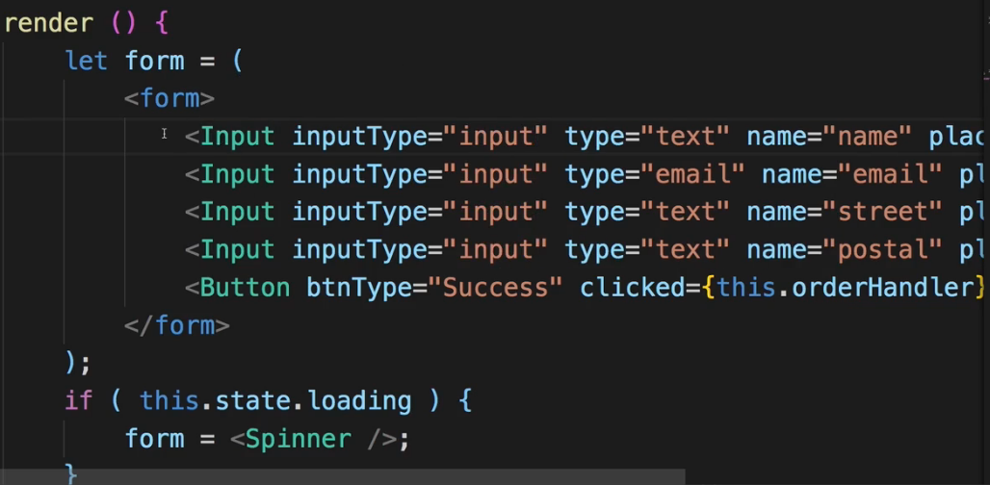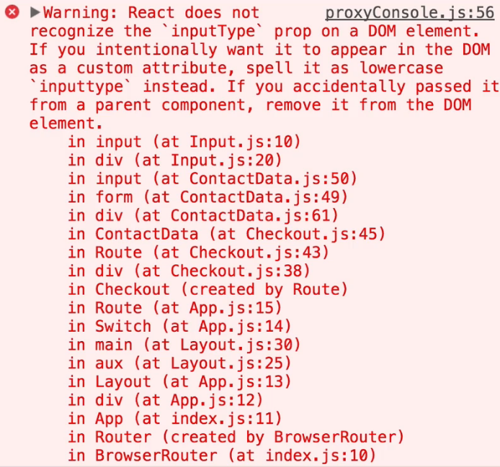  
=> This error message is stamming from a change in React 16.  
=> **It does pass on all props here and `inputType` due to its casing is not usable as a default HTML prop because HTML in the DOM is case insensitive. Therefore it throws this error. In the past prior to React 16, it wouldn’t have passed on this `inputType` prop which is doesn’t know. Now it does and it warns us that this is then invalid because of the casing**.  
=> **So 1 way to fix this is to simply change this to `inputtype` all lowercase**.  
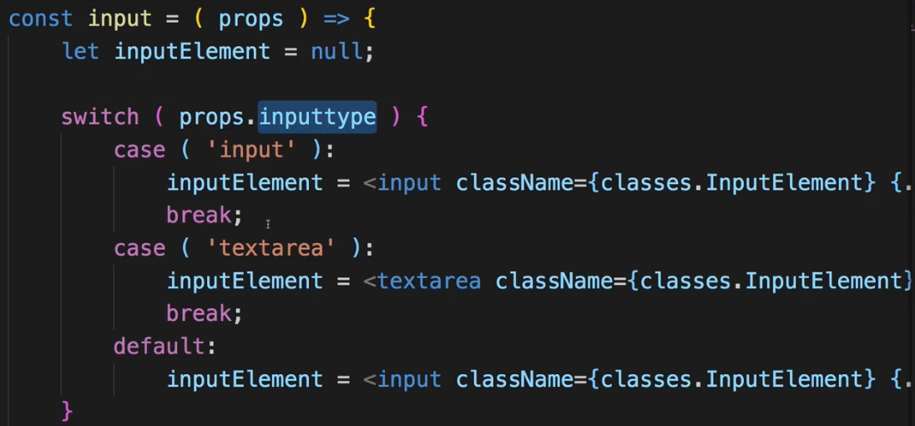  
**Setting Up a JS Config for the Form**  
* Let’s find a way to create our form dynamically and to clearly define how each element should look.  
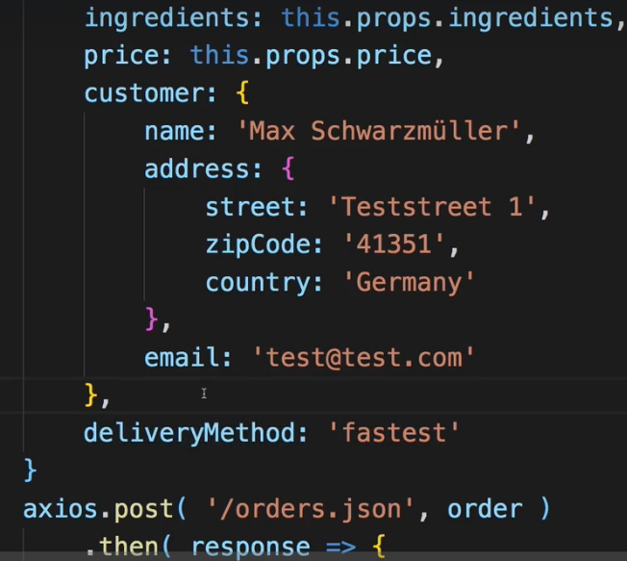  
* We’ve got some customer data like the name and address, and then we got this deliveryMethod. This could be a dropdown where we can choose between fastest and cheapest or something like that.  
* So for that let’s say we want to handle this form shape and all the element data in our state.  
* We want to define how this input should look so that we can really go through this object dynamically, that we could even add elements dynamically and create a fitting input element.  
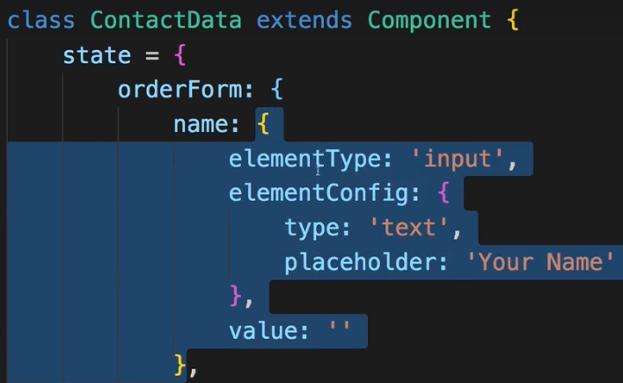  
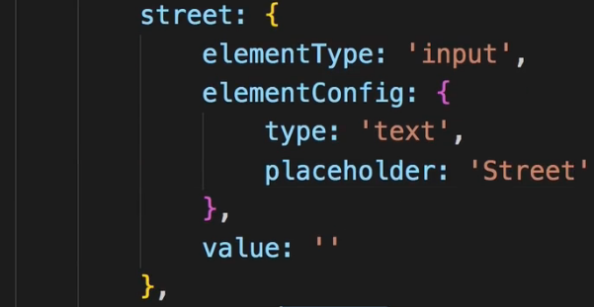  
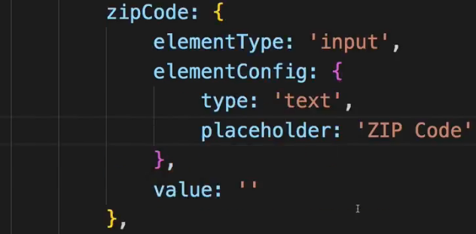  
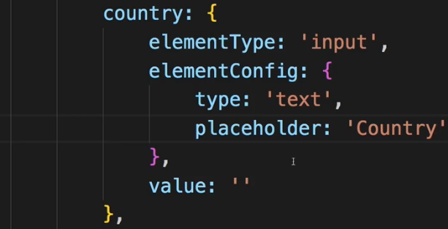  
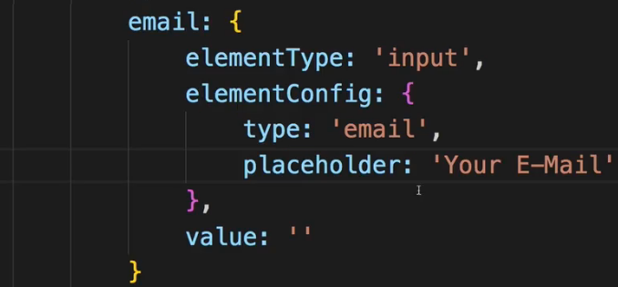  
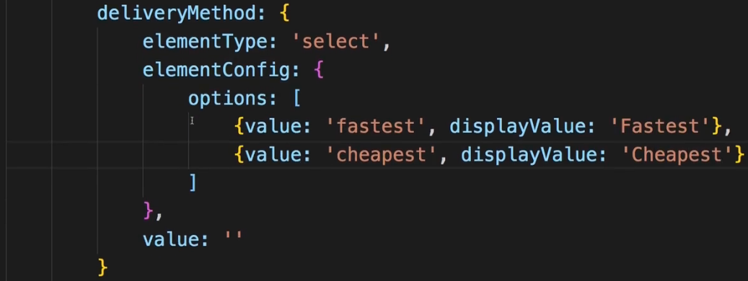  
* The elementConfig here could define the configuration, the normal attributes we can set up for the chosen HTML tag. This will be what I want to distribute over the created input.  
=> This is a pattern I want to repeat for all the elements.  
=> And you could of course write them with leaner code, you could create a helper function which creates just a JavaScript object so that here you just call a function which initializes it.  
* In the country you could of course use a dropdown instead of a text. I will use text because having a dropdown with restricted countries is a bit more complex and you would probably use some third-party package for that.  
=> So now we got this quite long orderForm with all the key-value pairs where we have some identifiers of our different form elements basically and then a JavaScript object with the configuration and setup.  
=> Now let’s adjust our Input elements to be able to work with that so that we can then dynamically create these inputs by just looping through our object which of course we have to transform into an array for that.  
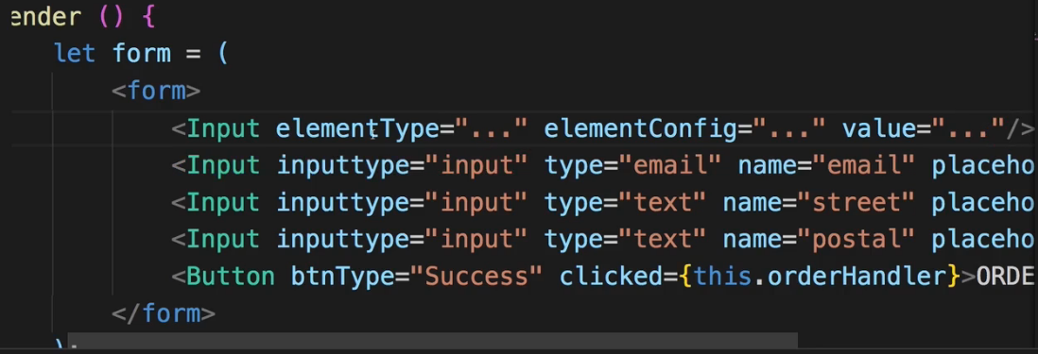  
* We don’t need to write this lowercase because I will change the way I distribute props on the created element.  
* Of course real values will be added soon.  
* Then let’s go into our Input.js element and in there now we receive different props, we have the `elementType` but then I no longer distribute all props - I just distribute `props.elementConfig`.  
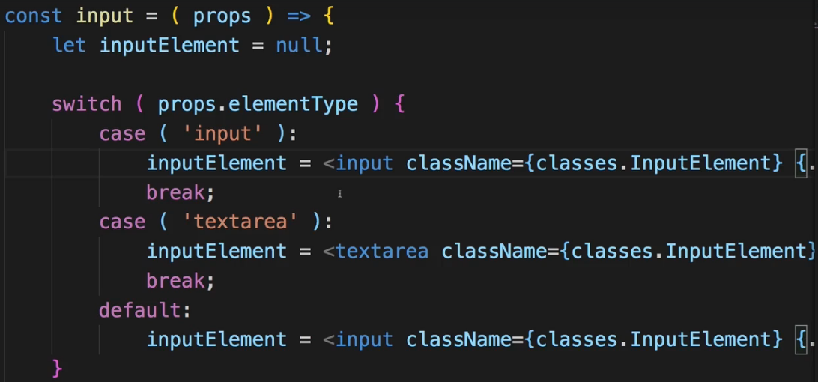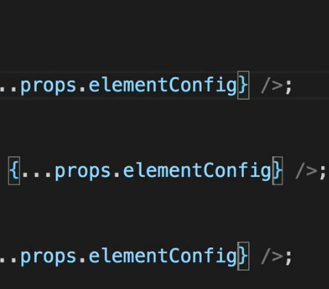  
* We also want to add the props.value and break it on multiple lines to make it easier to read.  
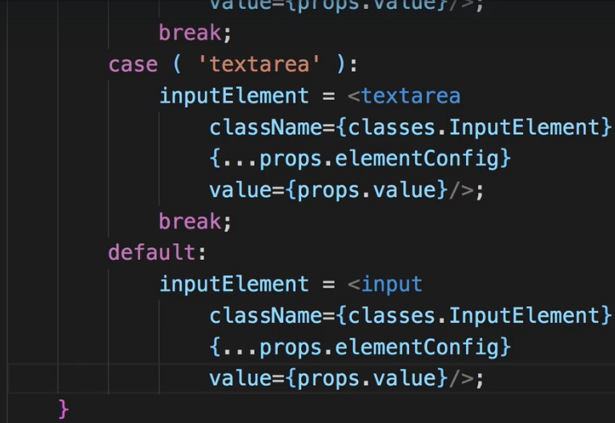  
* I now want to use our JavaScript form data we configured in the state to create the real input elements with it.  
**Dynamically Create Inputs based on JS Config**  
* First of all we need to turn our orderForm object we have in state into some kind of array I can loop through, an array where we basically have JavaScript objects where this key like `name` is just 1 property, and identifier property and then we also still have the other properties. There are always more ways of doing it.  
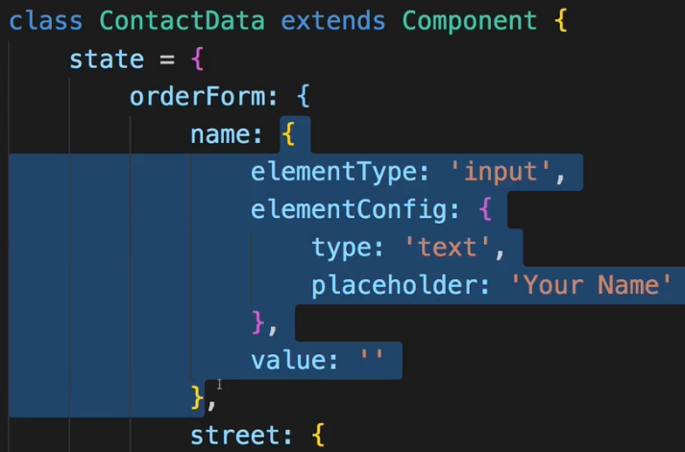  
=> `key` is name, street, zipCode.  
=> `orderForm[key]` are the values inside of it.  
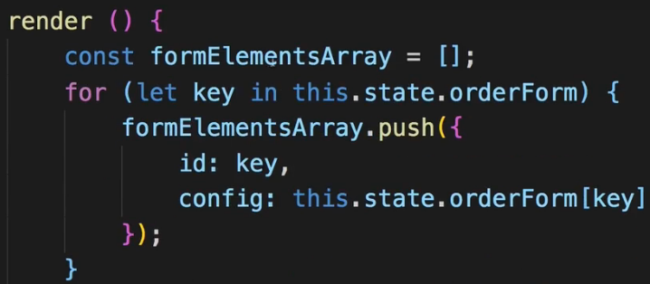   
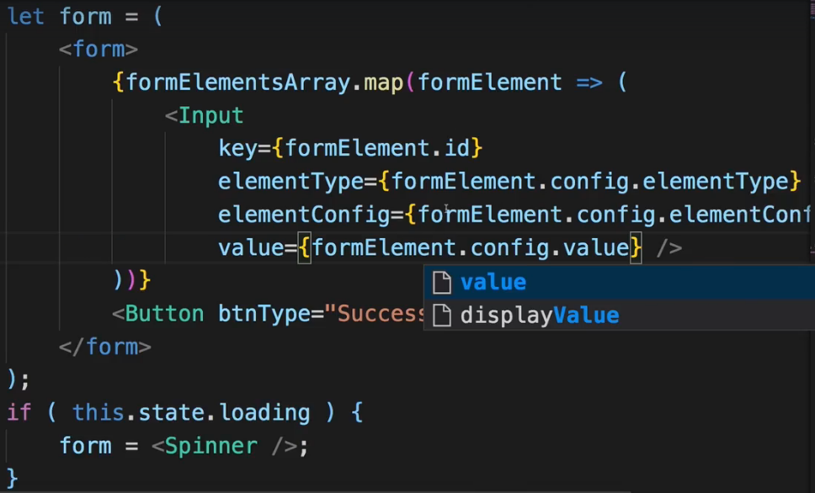  
* Now of course we want to make sure we can react to changes and that we also have a way of handling our dropdown because right now this is created incorrectly because of course here we have our switch statement - we handle inputs and textareas, but we also tried to create a select element.  
**Adding a Dropdown Component**  
* I use () so that I can write a multi-line JSX code.  
* Now the elementConfig I don’t want to pass it to this select element here because in my setup I only expect to get options let’s say. Of course there would be attributes you can set on select and you probably would have to define a nested config option in ContactData to have the normal attributes, but here in our case I only expect to get the options as my element config and I don’t want to distribute the options as attribute across my select statement here. Instead I want to set up options here.  
* And by the way, having that `value` on the select is important to make two-way binding work correctly and so on.  
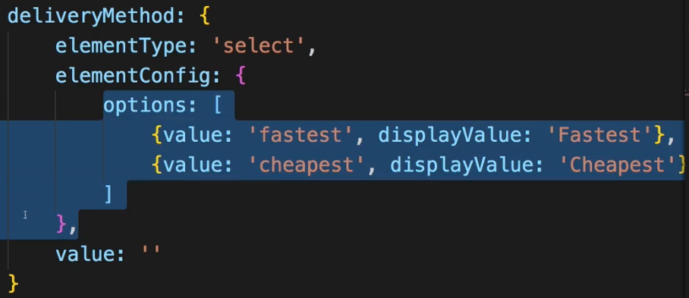  
* I want to create the options dynamically from this ^ options array I’m passing as part of the elementConfig. Mapping it into an array of JSX elements.  
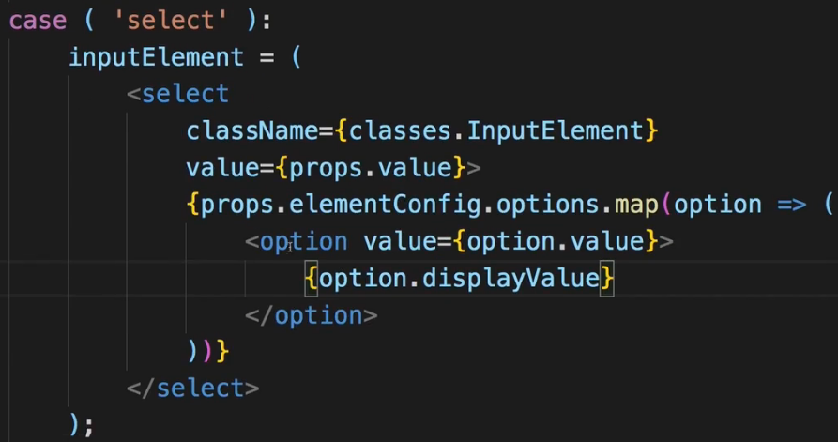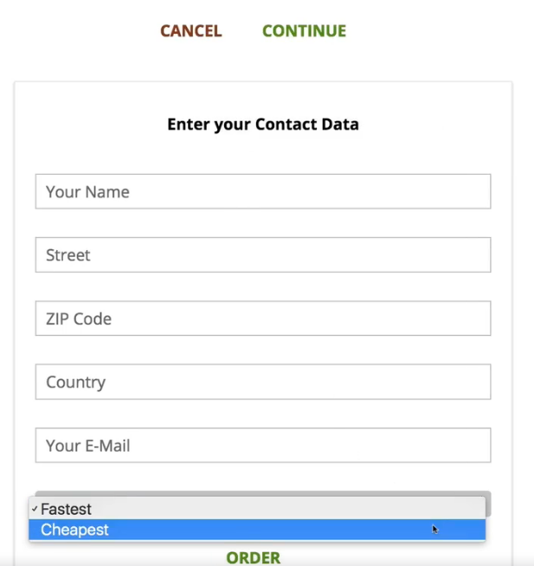  
* We also need to add the `key` property:  
  
**Handling User Input**  
* In Input.js component, each element of course should receive an onChange listener.  
=> Let’s add it to every element like this.  
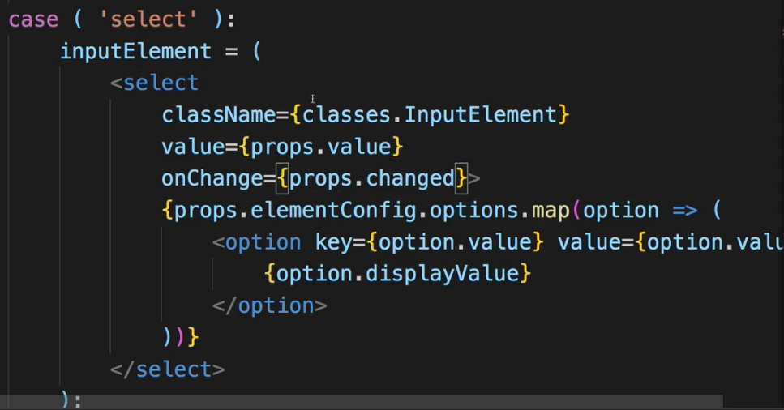  
* In ContactData I now need to implement the method.  
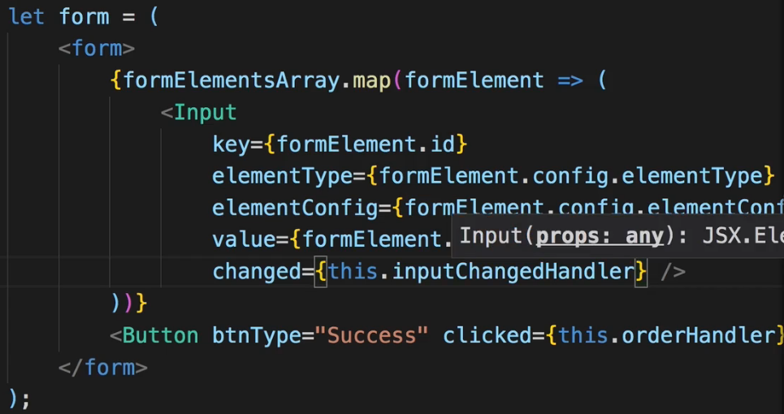  
* We need to update the value for a given input upon user changes.  
=> For that we also need a 2nd argument, which is the inputIdentifier so that we can reach out to our state, get the right element/object and adjust its value.  
* To do that I’ll go to ContactData and the method I pass to `changed`, the reference here, should be a reference to an anonymous function so that I can now pass arguments to the inputChangeHandler call.  
=> In this anonymous function here we now get this event object which is created by React automatically, and I want to pass this on but I also now want to pass my indentifier, which is formElement.id.  
  
=> That is this:  
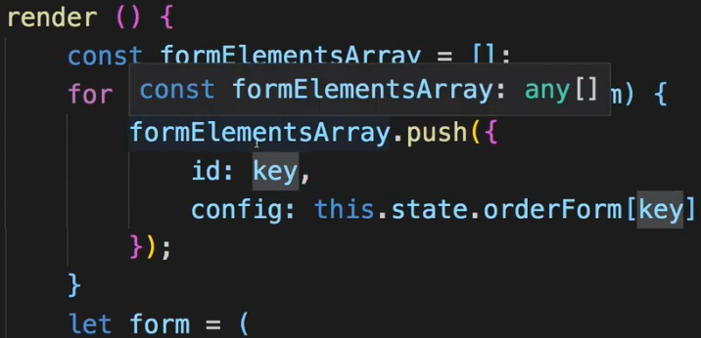  
ID which is just a key from our object and that’s exactly what I need (it’s the name, street, …).  
=> Now I can use that information to update the value.  
=> The problem just is I of course can’t access this.state.orderForm and the identifier and update the value - this is not how we mutate the state. Instead we have to mutate it immutably. And we do this with setState().  
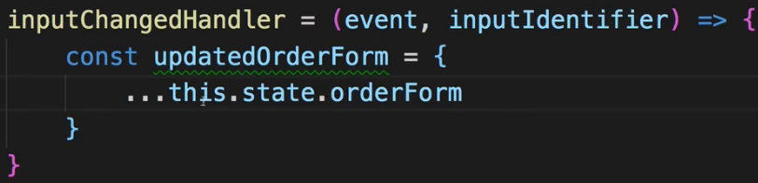  
=> **HOWEVER, this does not create a deep clone, so I copy that object and I distribute all the properties, I get a new object BUT since in this object I have more nested objects, these would not be cloned deeply, there I would again just copy the pointer to them and hence if I changed something there, I would still mutate the original state unfortunately because the object in my copied object and the object in the state would still be equal**.  
=> **So we need to clone this deeply**. How do we do that?  
=> Well in the end I only care about the `value` here:  
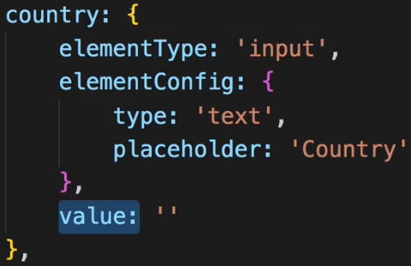  
=> So I only need to make sure that this object here:  
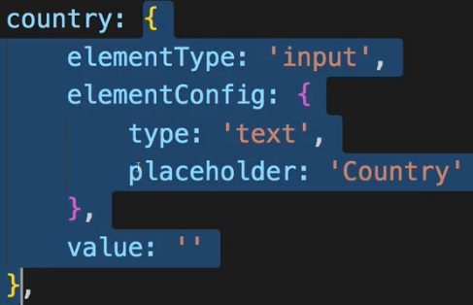  
is also cloned and I don’t point to the same object anymore.  
=> I can achieve this by not just distributing the properties of orderForm, which would be the name, street and so on, BUT that I also copy the properties inside my selected orderForm element deeply.  
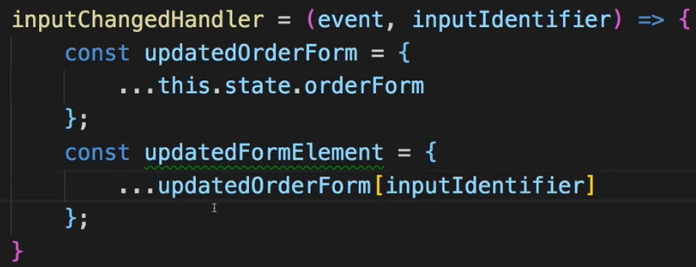  
=> Now I can safely change the value of the updatedFormElement because it is again a clone.  
=> If I wanted to change the elementConfig, I’d need to also clone that deeply with the spread operator.  
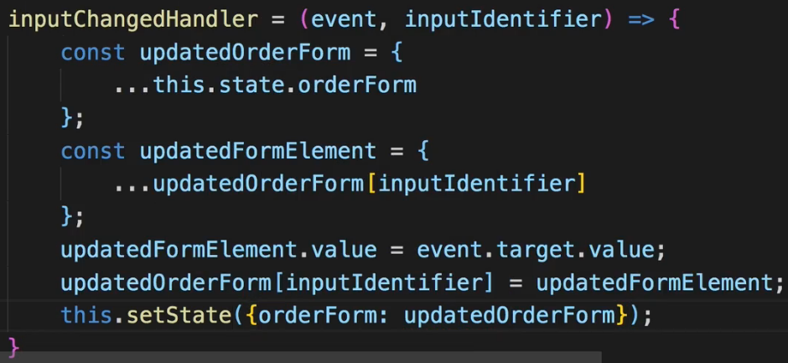  
* Two-way binding is now working. Now we successfully set this up in a very generic way, which is great.  
**Handling Form Submission**  
* We created a form which we simply set up in JavaScript and which we then handle dynamically with our own Input component and our inputChangedHandler() where we immutably update any affected form elements.  
* Now let’s make sure we can also submit this form.  
* Right now we had a clicked handler on our button but I don’t want to use the clicked handler.  
=> There actually is am `onSubmit` event handler we can use on the form itself.  
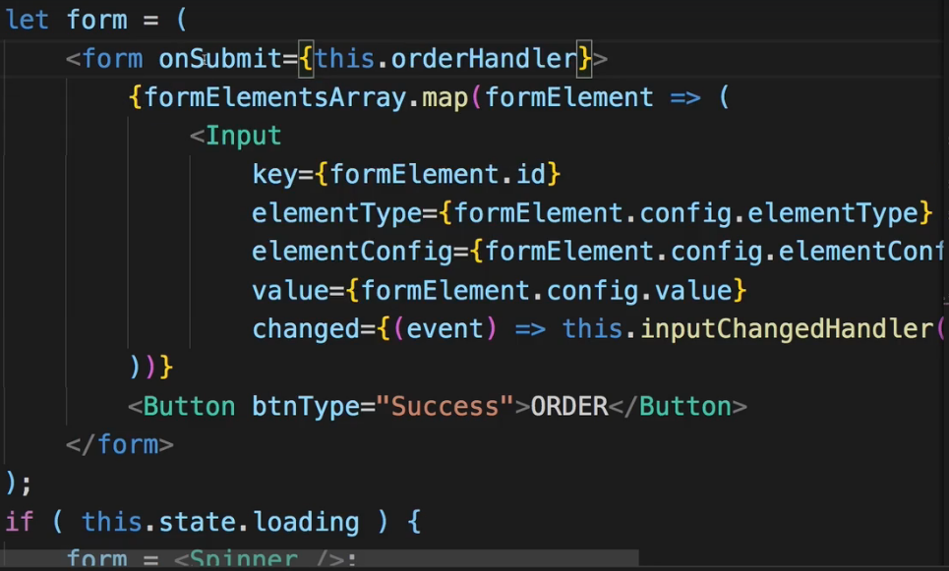  
=> Now in the orderHandler I of course still want to prevent the default because I don’t want to send a Request automatically - that would reload my page.  
=> Instead, I now need to extract the data I want to submit. And the cool thing is all the data is already managed in the state in our orderForm object which is updated all the time with Two-way binding - the value is updated at least and that’s what I’m interested in.  
=> Now from here:  
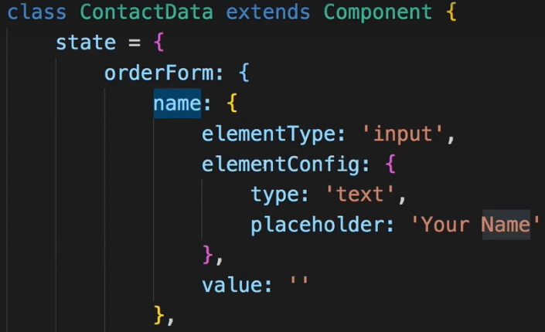  
I just want to get like the name and the value, directly mapped to each other. So I’ll transform it a little bit.  
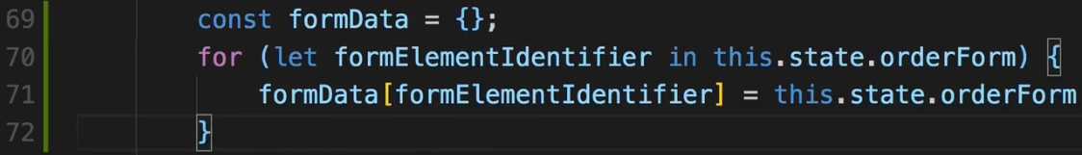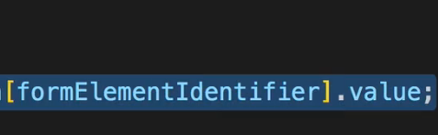  
* This formElementIdentifier is simply the name, street, …  
* With this I have that simple mapping, I can now use that to submit it.  
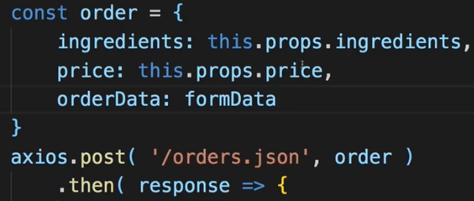  
=> So here my formData this is in the end what I want to pass.  
* Now the submitting of the form works just fine and in a very dynamic way. Look how easy it is to add a new input - you simply add a new property to your orderForm in the state - set up the elementType, configure it here and assign a value. And you quickly added a new input. And of course, since this is in the state, you can even manipulate this orderForm immutably at run-time. So you can dynamically add new properties and hence new inputs or remove them, or change the configuration.  
* That is why such a dynamic way of creating a form is so awesome.  
**Adding Custom Form Validation**  
* Now while the Framework like Angular has a built-in validation package basically, React doesn’t, you have to do validation on your own.  
* There are some third-party packages you might wanna check out but in general you can also build validation on your own.  
* Now the goal is that whnever we change the value so in the inputChangeHandle, we also check if it’s valid or not.  
* And of course the validity of element should be defined by some rules which we set up in the orderForm, so here for a given input where we also define the type and the config (basically the HTML attributes) and the value, we also might have some `validation:` key, where we set up rules we want to have respect.  
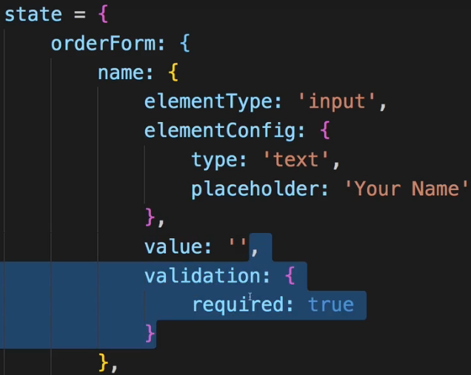  
=> Let’s use this required validation in all our elements so that it must not be empty.  
* I don’t need it in the dropdown because I have to select a value there anyways.  
* Let’s create a checkValidity() method with values and rules and arguments and this should return true or false.  
=> This also means that I have to have some `valid` property on each element in my state which I can manage.  
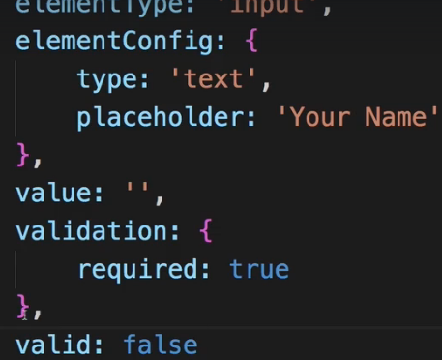  
* And you could of course add it as a sub-key of validation or something like that.  
* **.trim()** so remove any whitespaces at the beginning or at the end.  
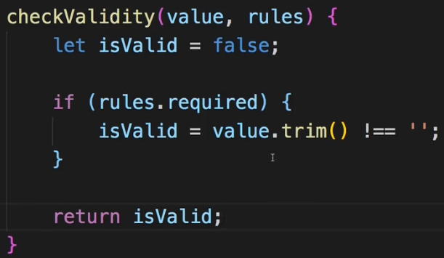  
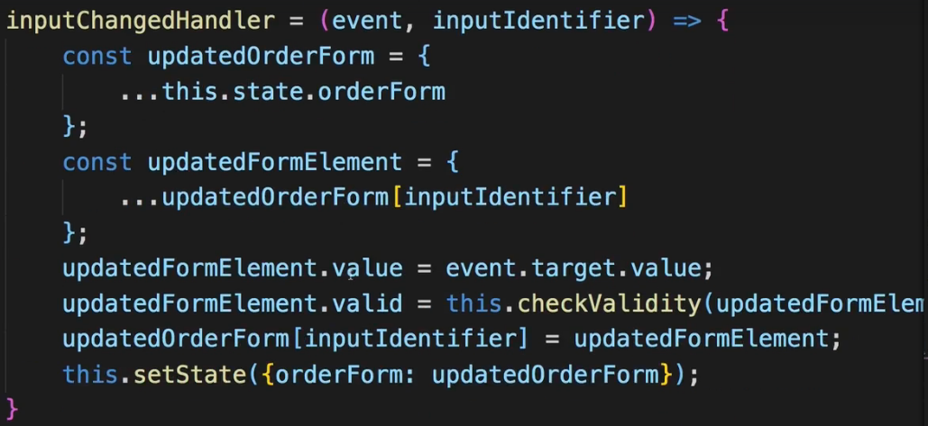  
=> passing: `**updatedFormElement.value**` and `**updatedFormElement.validation**` to the function.  
* Now of course we could add more rules such as: minLength.  
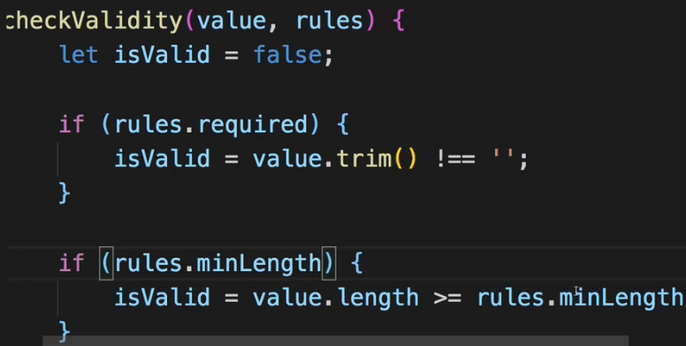  
* And of course you can be creative and even create more complex rules which might have objects as a value where you can access rules.minLength and then something like rules.minLength.absoluteMin or something like that.  
* I’ll use the minLength rule here for the zipCode.  
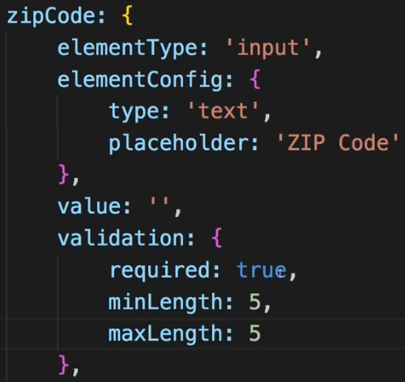 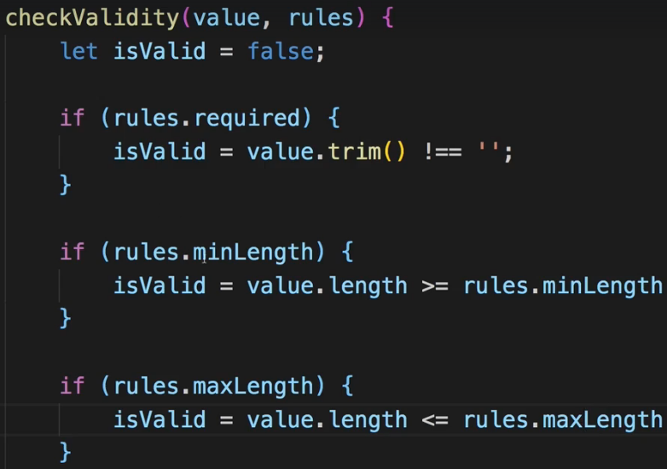  
=> **Our current validation logic here has a crucial flaw by the way - we check 1 rule after the other, that means that of course only the last rule has to be satisfied to turn isValid to true. Even if minLength sets isValid to false, if maxLength is true, isValid will be set to true again**.  
**Fixing a Common Validation Gotcha**  
* What we can do to fix this is set isValid to true by default and add && isValid to each rule:  
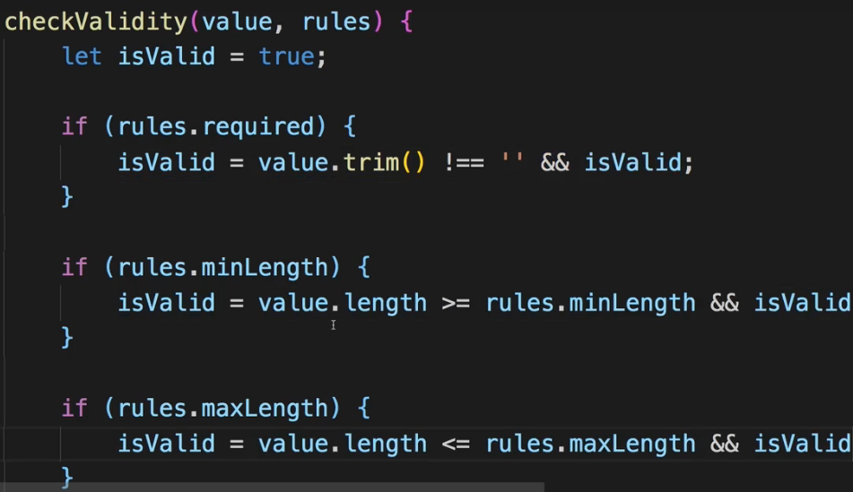  
* All the rules now have to resolve to true.  
**Adding Validation Feedback**  
* To output feedback, I have to go to my Input.js component and there for each input element I in the end want to add a special class to that element if it is invalid. So my classes here have to become more dynamic.  
* We start with:  
  
because we always want to attach this at least.  
=> Now on the individual elements I’ll replace classes.InputElement with the inputClasses array and I’ll .join(‘ ’) it with a whitespace.  
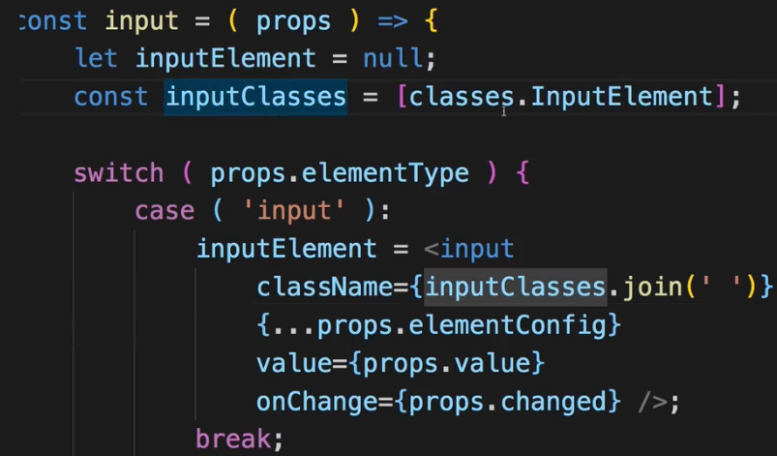  
* Now we .push() a special class to it if it’s invalid.  
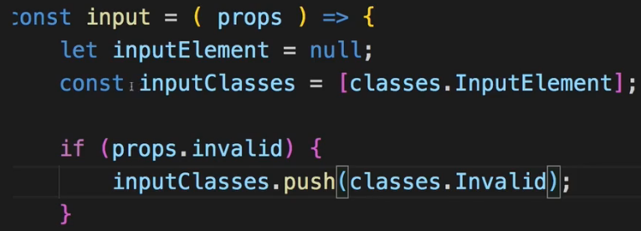 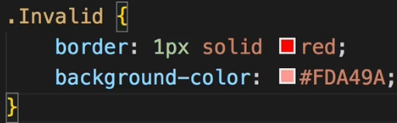  
=> Now we need to pass that `invalid` property in ContactData to the Input.  
* The `config` refers to this highlighted part:  
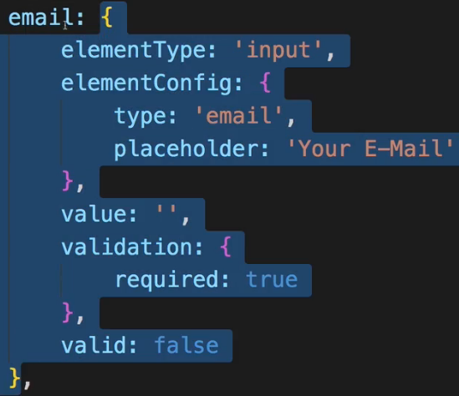  
=> We use `!` because we want to pass invalid instead of valid.  
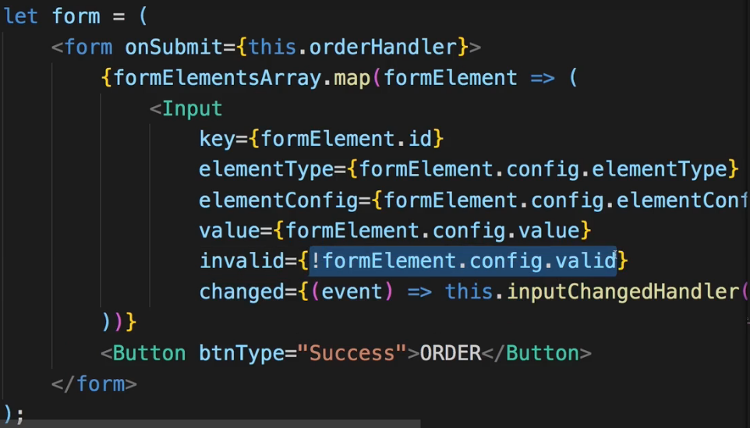  
* Now it’s working.  
* However, it’s not friendly to start with a form which is just red. We can also see that our dropdown is always red even though we have no validation rules there. So we need some fine-tuning.  
* Let’s start with the dropdown.  
=> **We shouldn’t always add .Invalid like for a dropdown where we have no rules**.  
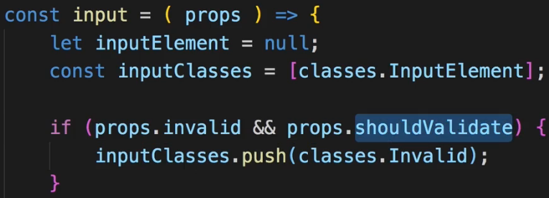  
=> **`shouldValidate` should only be true if my object in the orderForm has a `validation` object**.  
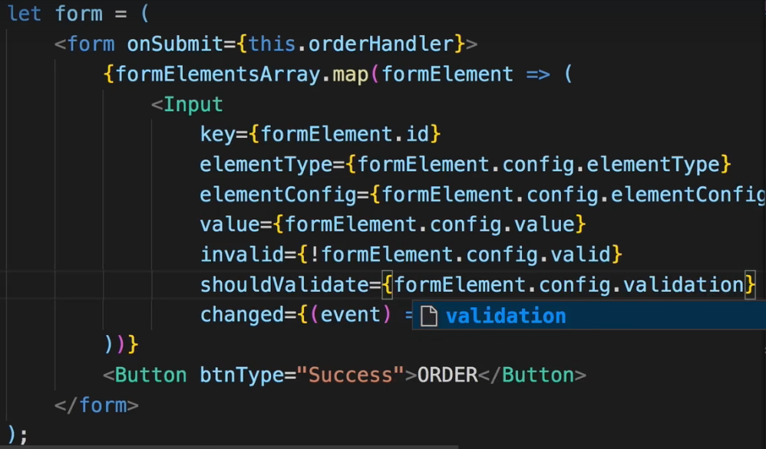  
=> **If the `validation` property isn’t set, as for my dropdown, this will return false and therefore the check in Input.js will not run and will never get the invalid class**.  
**Improving Visual Feedback**  
* We probably don’t want to start with a form that is all red.  
=> For that we have to track whether a user already touched an input or not.  
=> So in ContactData I want to add a new property to each form element in orderForm object.  
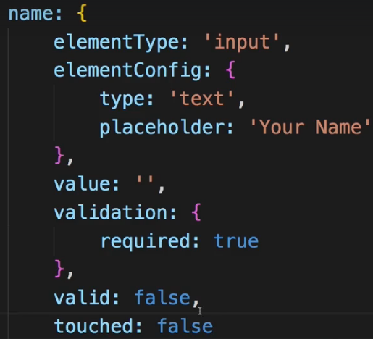  
=> I can then make sure that I only check the validity if the element was touched.  
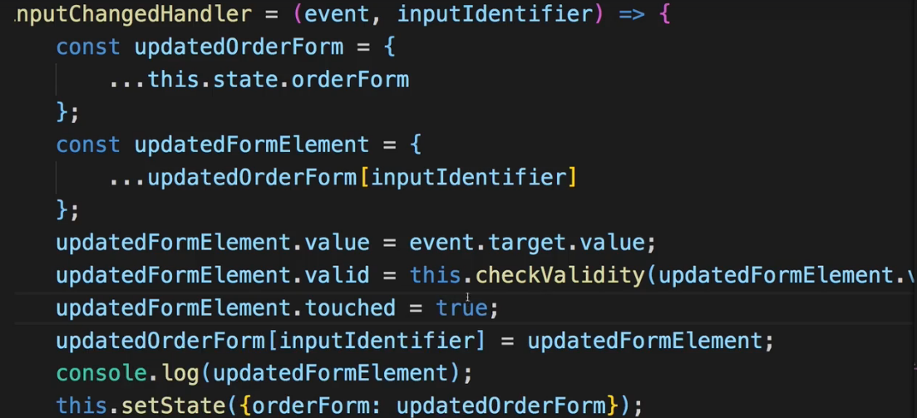  
=> Setting the `touched` to true in the inputChangedHandler() method.  
* Now I only want to add this invalid class if the element has been touched. So I’ll pass this `touched` property to Input components.  
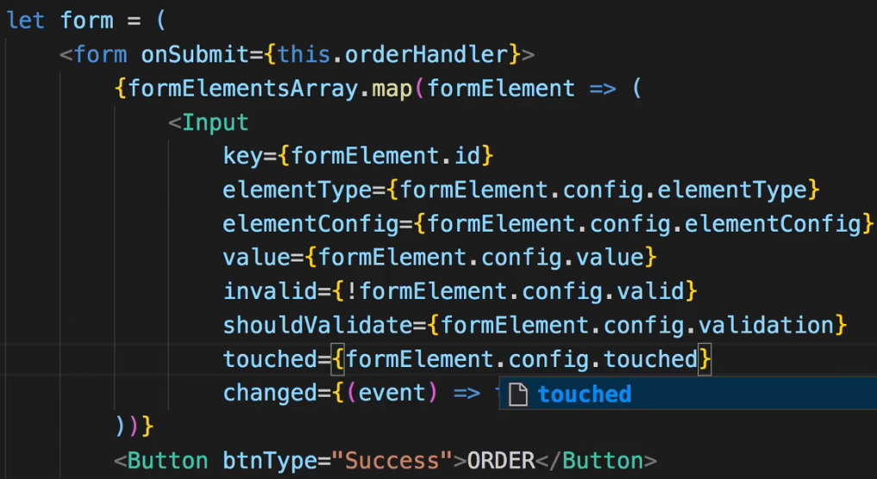  
* Now in Input.js:  
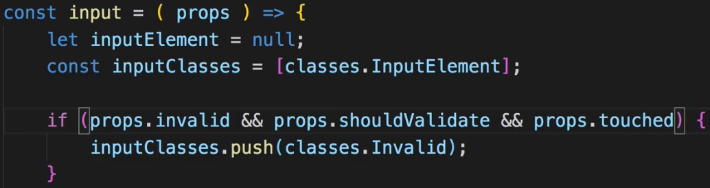  
* Now let’s also make sure that we can’t submit the form while it’s invalid.  
**Showing Error Messages**  
We're not showing any error messages in our form, but you can of course easily add some.  
The form inputs (<Input />  component) already receives the information whether it's invalid or not. You could of course easily add some conditionally rendered element inside of that component.  
For example (inside <Input />  component function):

1. // all the other code from the videos
3. let validationError = null;
4. if (props.invalid && props.touched) {
5. validationError = <p>Please enter a valid value!</p>;
6. }
8. return (
9. <div className={classes.Input}>
10. <label className={classes.Label}>{props.label}</label>
11. {inputElement}
12. {validationError}
13. </div>
14. );

This could of course be finetuned. You could also pass the value type (e.g. "email address" ) as a prop:  
validationError = <p>Please enter a valid {props.valueType}</p>;   
You could also receive the complete error message as a prop:  
validationError = <p>{props.errorMessage}</p>;   
And of course, also don't forget to style the messages if you want to do that:  
validationError = <p className={classes.ValidationError}>{props.errorMessage}</p>;  
In your CSS file, you could have:

1. .ValidationError {
2. color: red;
3. margin: 5px 0;
4. }

**Handling Overall Form Validity**  
* I need to find out if my overall form is valid or invalid.  
* There are of course a couple of ways to do this.  
* For example we could add a controls = [] array to our orderForm and now add all the controls (name, street, …) to that and then add another property which is valid: for the overall form. And we update this whenever a user enters values.  
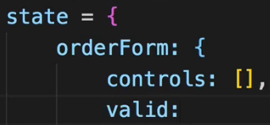  
=> This would require quite some refactoring here and it’s only 1 approach.  
* We can of course also simply add a new property in our state so AFTER OUR orderForm so next to `loading` we could add a `formIsValid` property.  
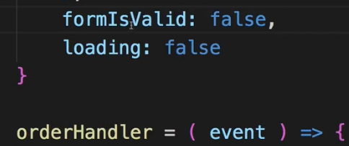  
* And now in inputChangeHandler whatever we type I in the end want to check if all elements are valid right now. And if they’re all valid, I’ll set this `formIsValid` state property to true.  
* In ContactData in the inputChangeHandler() method.  
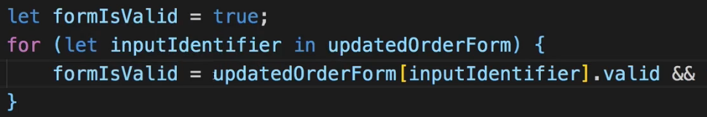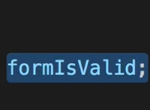  
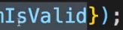

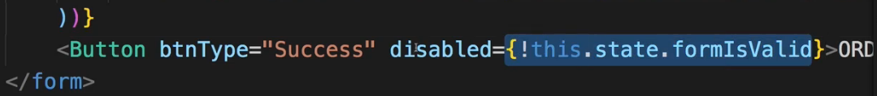  
* **Right now the Button isn’t updated with the state of our form, it’s not really using our validity. Why?**  
=> **Because we use our own Button element and there we don’t know `disabled` property**.  
* In Button.js:  
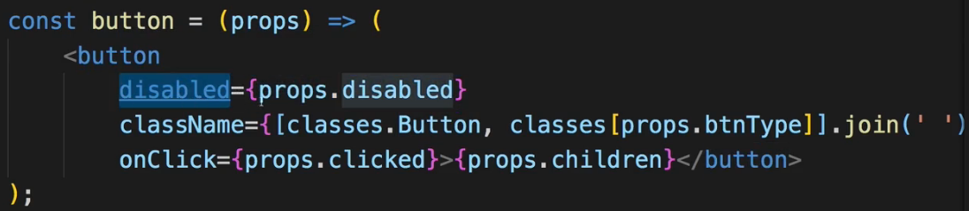  
* Now it is disabled at the start.  
* **Now if the whole form is valid, it still doesn’t enable the button. Why?**  
=> **In the ContactData.js it looks like we’re not setting formIsValid to true even if the whole form should be valid**.  
=> **If we check it in console.log(), it’s constantly UNDEFINED**.  
=> **This is related to our inputs. Remember we have this dropdown which doesn’t have any validation rules attached to it, now it also doesn’t have a `valid` property therefore. And if we then loop through all the elements and use this `valid` attribute it of course isn’t true/false for the dropdown, it’s undefined and undefined is always treated as false but it also never changes to true**.  
=> So the way to fix this is to simply still add this `valid` property to the dropdown even though it of course doesn’t have any validation rules but therefore it should always be valid.  
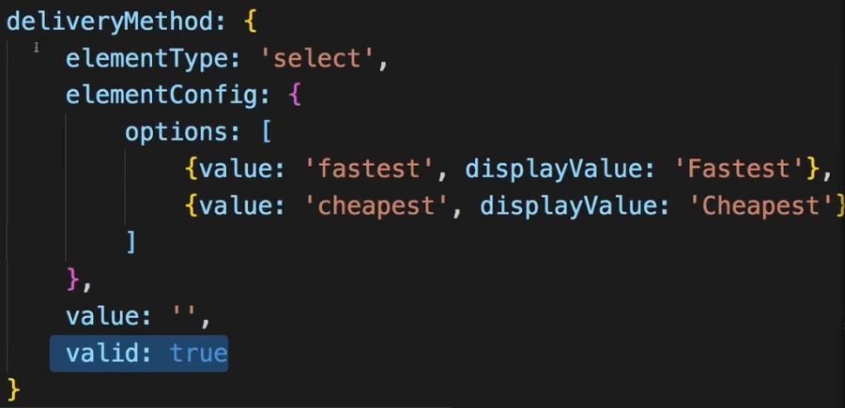  
* Now let’s add a special styling to the button if it’s `disabled`.  
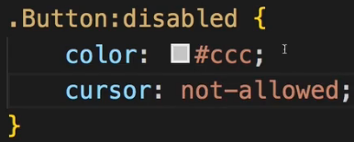  
* **cursor: not-allowed**.  
* Right now if we change the value in our dropdown, we actually get an error message related to our validation.  
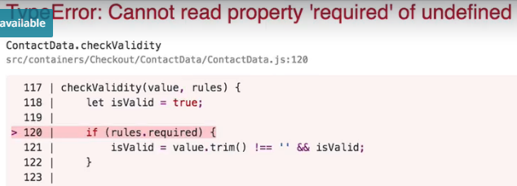  
**Wrap Up**  
* We detected this error when we changed the value of our dropdown.  
=> It is related to our validation check in the ContactData container.  
=> There in checkValidity(value, rules) we check if `rules.required`, the problem is `rules` - what does this `rules` refer to? We call this function in inputChangeHandler and we pass:  
  
=> This `validation` object doesn’t exist for the dropdown - the deliveryMethod in state.  
=> Trying to access something on undefined gives us an error.  
* There are 2 ways of fixing that.  
=> 1. => **Add an empty validation: {} object to the dropdown - deliveryMethod. Now accessing validation will not fail but simply return undefined**.  
=> I like this way a lot because now all our controls are set up equally. They all have a `validation` property, and a `valid` property. And if they don’t need validation, then it should just be empty.  
=> 2. => The alternative would have been to also add a check in checkValidity(value, rules) and see if rules is not truish then simply return true.  
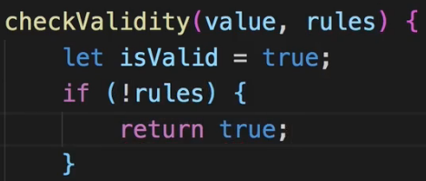  
**Fixing a Bug**  
* I noticed a bug after recording this module.  
* It’s not a severe one, we’re going to fix it later in this course.  
=> In our ContactData.js container where we have the state managing our form controls, deliveryMethod, that’s our select element. There I set a value: ‘’ of empty string initially. Now we have the options fastest or cheapest. An empty string doesn’t make much sense - on the UI we will see fastest and cheapest but if we never switch the option, behind the scenes the value will always stay an empty string, it will always be updated once we trigger onChange so once we did change the value once.  
=> This will become an issue later when we submit our form to the server, then we’ll actually submit an empty value in case we never switch the value.  
* Again, I will fix it later in the course.  
* The fix is as easy as simply entering fastest or cheapest as the default `value`.

**Validate.js (you may import its functionality into your React projects)**: <https://validatejs.org/>   
**Get more ideas about potential validation approaches**: <https://react.rocks/tag/Validation>  
**Alternatives to the manual approach taken in this course**:  
**react-validation package**: <https://www.npmjs.com/package/react-validation>  
**formsy-react package**: <https://github.com/christianalfoni/formsy-react>